Commodore CBM8296 Diagnostic: Keyboard Dongle Rev. 0  
Module Description

# Introduction

This Keyboard Dongle is part of the diagnostic clip set for the Commodore CBM8296. The original Commodore part number is 324803-01. The feedback signals are directly wired to a D-Sub connector (25 pins, male). This Keyboard Dongle is based on a PCB.

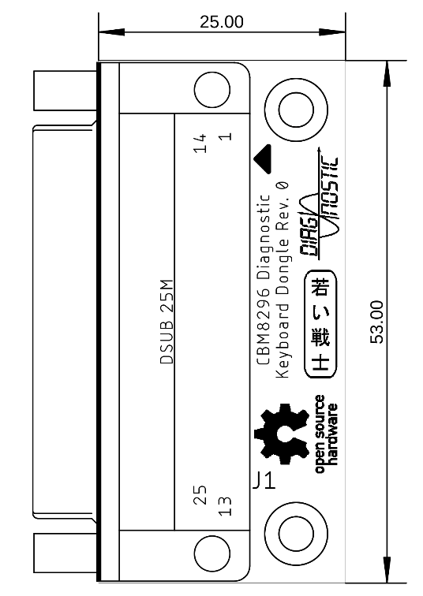

Figure 1: Dimensions of the Keyboard Dongle

# 3D-printed Case

The STL-files of the case are provided in the respective sub-folder of this project as is the label print.

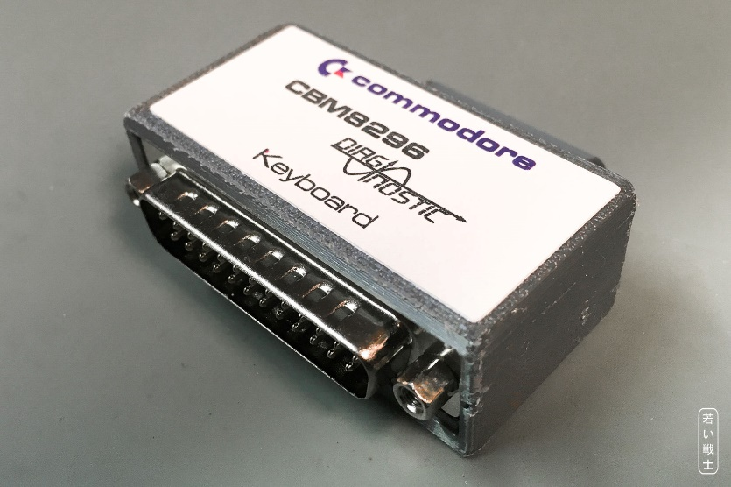

Figure 2: CBM8296 User Port dongle in a 3D printed case with label

Recommended screws: 2 each of C2.9x6.5 self-tapping screws for sheet metal (C 2,9x6,5H, DIN 7981).

# Connections

|  |  |
| --- | --- |
| Connection | Signals |
| 1-9-14 | DEC0 – DEC8 – KIN0 |
| 2-10-15 | DEC1 – DEC9 – KIN1 |
| 3-16 | DEC2 – KIN2 |
| 4-17 | DEC3 – KIN3 |
| 5-18 | DEC4 – KIN4 |
| 6-19 | DEC5 – KIN5 |
| 7-20 | DEC6 – KIN6 |
| 8-21 | DEC7 - KIN7 |

# Revision History

## Rev. 0

* Prototype, not yet tested.